

[Document title]

[Document subtitle]



[Date]

[Company name]

[Company address]

Contents

List of Figure 2

Problem 01 3

Code 3

Output 3

Problem 02 4

Code 4

Output 5

# List of Figure

Figure 1: Graph 2

Figure 2: Time to touch earth 3

Figure 3: Displacement Vs Time 4

Figure 4: Normalize Graph 5

# Problem 01

## Code

clc

clear all

V0=20;

theta=60;

g=9.8;

Vx=V0*cosd(theta);

Vy=V0*sind(theta);

t0=0;

t1=(2*V0*sind(theta))/g

time=linspace(t0,t1,100);

Output=V0*sind(theta).*time - (g.*time.^2)./2;

plot(time,Output)

xlabel('Time ')

ylabel('Height')

title ('Trajectory')

grid on

## Output

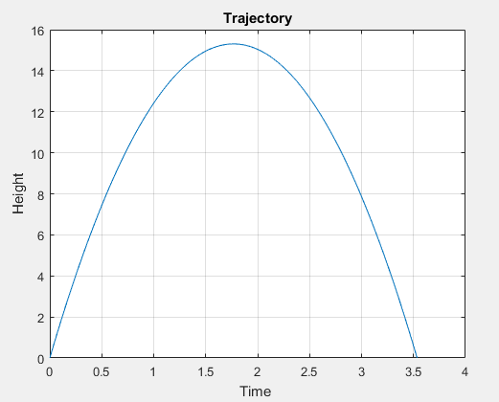

Figure : Graph

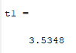

Figure : Time to touch earth

# Problem 02

## Code

clc

clear all

close all

A=20;

w=3;

time=0:0.01:20;

displacement=A*sin(w.*time);

figure(1)

plot(time,displacement)

title ('Original Plot ')

xlabel('time')

ylabel('Displacement')

for i=1:length(displacement)

if (displacement(i)>0)

displacement(i)=max(displacement);

else

displacement(i)=0;

end

end

figure (2)

histogram (displacement)

title('Count the Max and zero in displacement')

xlabel('time')

ylabel('Quantity')

## Output

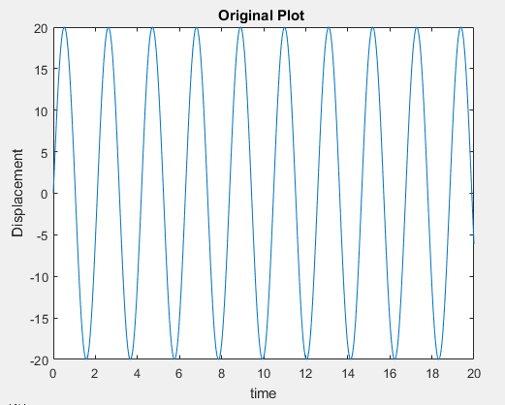

Figure : Displacement Vs Time

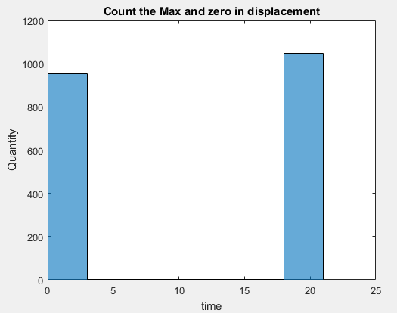

Figure : Normalize Graph